DC HeroClix: Royal Flush Gang Storyline Organized Play Event Series
Instructions Sheet

Events are run using a special variant of the Battle Royale drafting and game play format called Battle Royale Flush!
Battle Royale Flush is a Battle Royale variant (see "Battle Royale Game Format" section for more details on the Battle Royale game format) for the Royal Flush Gang Storyline Organized Play Event. To play, a standard deck of playing cards (not included in the kit) must be provided. If you don’t have a standard deck of cards, you can just play normal Battle Royales for your event. During game setup, the Jokers are removed from the deck and the deck is shuffled. Each player is dealt a hand of two cards, then five cards are placed face down as a shared pool.
When a player KOs an opposing character, after resolutions they may discard a card from their hand (face up) to draw a new card from the deck. If the deck is empty when a card would be drawn from it, shuffle the discard pile back into the deck before drawing.
At the end of the game, reveal any face down cards in the shared pool. Each player scores bonus victory points based on the best hand they can form by combining their cards with the shared pool. Hands are scored as follows:
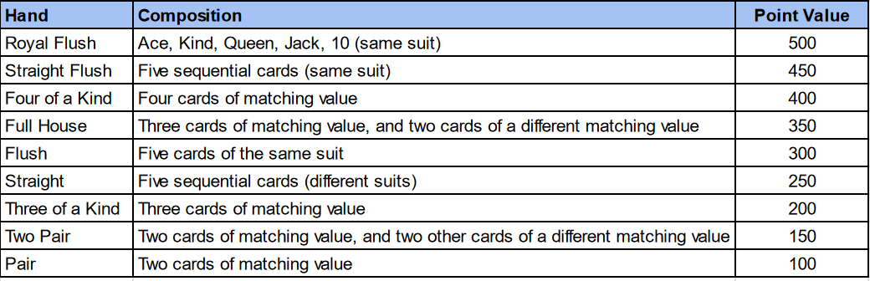

Steps for Running the Royal Flush Gang Storyline Organized Play Battle Royales:
Step 1: Prepare Materials
Each Battle Royale will require the following before drafting begins:
- 1 Map
- 4 HeroClix booster packs (1 per player)
- 1 deck of standard playing cards (Jokers removed, not included)
Step 2: Pre-Draft
- Each player opens their packs and confirms contents.
Step 3: Pass Draft of Figures
- Starting with the pack that they opened, each player chooses a figure that they wish to draft to their team and takes its associated character card, then passes the remainder of the pack to the player on their left.
- When they receive a booster pack from the player on their right, players then choose one of the remaining figures in that pack (along with its associated character card) to draft into their force then passes the remainder of the pack to the player on their left.
- The above step is repeated three more times. Each player will end up with 5 figures plus their associated character cards. If you’re using a booster set that has more or less figures, all players should still end up with the same number of figures as came in the booster.
Step 4: Play Game
- Event organizer/judge will start the clock.
- Roll dice and have fun!
- Ask your event organizer if you have any questions during the game.
Step 5: Determine Player Placement & Award Tournament Points
- Placement of players from 1st Place to 4th Place is determined by the highest total points of game elements KO’d during the game.
- Players are awarded Tournament Points that count towards winning the Grand Prize for the Royal Flush Gang Storyline Organized Play series according to the chart below:
o 1st Place: 4 Tournament Points (TPs)
o 2nd Place: 3 Tournament Points (TPs)
o 3rd Place: 2 Tournament Points (TPs)
o 4th Place: 1 Tournament Points (TPs)
Step 6: Award Participation Prizes & Snake Draft figures according to Player Placement
- Participation Prizes: The event organizer gives each player a Participation Prize.
- Place all figures and their associated character cards where all players can see them like onto the map.
- Starting with the 1st Place player, each player chooses a figure to add to their personal collection.
- After the 4th player chooses, that same player chooses again. From there the draft order is reversed to 3rd, then 2nd, then 1st. 1st Place player then chooses again, and draft order reverts back to 2nd, then 3rd, then 4th.
- Continue the above process until all figures have been drafted.

Battle Royale Game Format:
Check out the Battle Royale format here – https://wizkids.com/heroclix/battle-royale

Players are awarded Tournament Points (TPs) that count toward winning the Grand Prizes for the Royal Flush Gang Storyline Organized Play series according to the chart below:
o 1st Place: 4 Tournament Points (TPs)
o 2nd Place: 3 Tournament Points (TPs)
o 3rd Place: 2 Tournament Points (TPs)
o 4th Place: 1 Tournament Points (TPs)

If there’s a need for a tiebreaker, stores can use a method of their choice, but we recommend using one of the following:

- Final event Tournament Points
- Play additional head-to-head matches
- Roll-off

Prizes for each event:
The suggested prize for each event is as follows:
- Event 1 – Ten
- Event 2 – Jack
- Event 3 – Queen
- Event 4 – King
- Grand Prize – Ace
The Team Up and Legacy cards can be given out at the discretion of the store.

